Task Scheduler
Problem Statement: You are given a list of tasks represented by uppercase English letters ('A' to 'Z'), and an integer n representing a cooldown interval between two same tasks. Each task takes exactly 1 CPU interval to complete. Tasks can be executed in any order, but identical tasks must be separated by at least n intervals, during which the CPU may remain idle or execute other tasks.
Return the minimum number of CPU intervals required to complete all the tasks.
Input : tasks = ["A","A","A","B","B","B"], n = 2
Output : 8
Explanation : One valid execution order is: A -> B -> idle -> A -> B -> idle -> A -> B Total intervals = 8
Algorithm
We want to execute all given tasks such that the same task type appears at least n time units apart. One brute force way to do this is by simulating the process. We use a max heap to always pick the task with the highest remaining frequency. In each unit of time, we execute a task if possible otherwise, we insert idle time. This approach ensures we respect the cooldown constraint but may add unnecessary idle time due to its greedy nature.
- Count the frequency of each task using a hash map.
- Push all frequencies into a max-heap (priority queue).
- While the heap is not empty:
  - Initialize an empty temporary list to hold tasks in current cycle.
  - For a total of (n + 1) units of time, try to execute the most frequent remaining task:
    - Pop the task with highest frequency from heap.
    - Decrement its frequency and store it in temporary list if it still has counts left.
    - Increment total time for each executed or idle unit.
  - Push all tasks from the temporary list back into the heap.
- Return total time taken including idles.
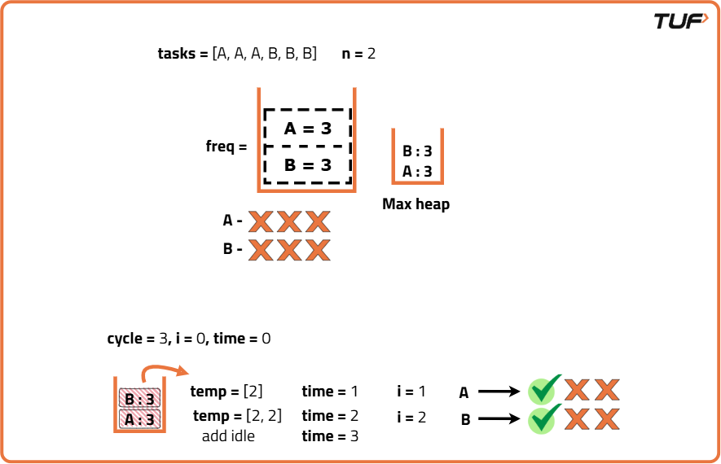

class Solution {
public int leastInterval(char[] tasks, int n) {
Map<Character, Integer> freq = new HashMap<>();
for (char task : tasks) freq.put(task, freq.getOrDefault(task, 0) + 1);

// Step 2: Create a max heap (priority queue in reverse order)
PriorityQueue<Integer> maxHeap = new PriorityQueue<>(Collections.reverseOrder());
for (int count : freq.values()) {
maxHeap.add(count);
}

// Total time required
int time = 0;

// Step 3: Process tasks in cycles of size (n + 1)
while (!maxHeap.isEmpty()) {
// Temporary list to store tasks of current cycle
List<Integer> temp = new ArrayList<>();

// Set cycle size as cooldown + 1
int cycle = n + 1;

// Track number of tasks processed in current cycle
int i = 0;

// Run up to (n+1) tasks or until heap is empty
while (i < cycle && !maxHeap.isEmpty()) {

// Pick the most frequent task
int count = maxHeap.poll();

// Decrease frequency since task is used once
count--;
// If task still remains, store it for next cycle
if (count > 0) temp.add(count)
// Count 1 unit time for this task
time++;
i++;
}
// Step 4: Push remaining tasks from temp back into the heap
for (int rem : temp) maxHeap.add(rem);
// Step 5: If heap is not empty, add idle time
if (!maxHeap.isEmpty()) time += (cycle - i);
}
// Return total time taken
return time;
}
}

